Vehicle Identification via Deep Learning Vision Technology

Friday, February 22, 2019 | Revised April 7, 2019

**Project: Identify the vehicle and its content, using Deep Learning (Neural Network) Vision Technology**

**Goals:** Primary goal of the project is to develop the ability to identify a specific vehicle (like make, model, and series) using visual cues from interior images of the vehicle using digital recognition technology aided by deep learning. A stretch goal is to also identify as many of its content characteristics, without a deep dive into the BOM of the product.

**Need:** The need to establish specific content of each vehicle is articulated by the following use case examples:

1. Need to quickly determine the content of the vehicle, in case of an accident, to understand the potential risks involved (gasoline vehicle risks are different from electrical motor vehicle risks)
2. Identify vehicles that are require any special tools/equipment for repair and maintenance
3. Identify vehicle content to ensure that proper mechanical and software updates are delivered (via dealership or OTA - Over the Air)
4. Understand vehicle content to confirm the ability to deliver "subscription services" to the vehicle

Some of these capabilities are being commercially developed for use in law enforcement, traffic data collection, security threat monitoring and surveillance. A more comprehensive toolset to identify additional parameters that can help identify specific content needs to be developed. This can be best done when working with an Automotive OEM, since many of the content build rules can be incorporated into the algorithms.

**Conceptual Approach:** Develop deep learning algorithms using digital imaging that automatically learns vehicle specific "distinguishable landmarks" to identify the specific vehicle. In addition to the "high level" identification like Make, Model and Series, the project also aims to generate deep learning networks to identify additional secondary and tertiary content of the vehicle (propulsion type, SYNC2 or SYNC3, Heated Seat or Heated/Cooled Seat, BLIS or no BLIS, etc.)

Specific to Ford vehicles, order guide data would be provided to determine the "macro-level" content for each vehicle type, but due to significant customer driven optionality, the content of the vehicles can be very different. It is postulated that deep learning algorithms can automatically learn to identify the lower level features (edges, contours) as well as higher level features (vents, steering wheels).

**Dataset Collection and Specification:**

* Collect/generate interior image dataset for several vehicle models (e.g., five models such as Ford Explorer, Fusion, Edge, Mustang, Chevrolet Equinox).
* Each model should contain at least 500 images of vehicle interior (primarily instrument panel).
* Label each image with contours of at key internal objects such as manufacturer logo on the steering wheel, central display, gear stick, right air vent.

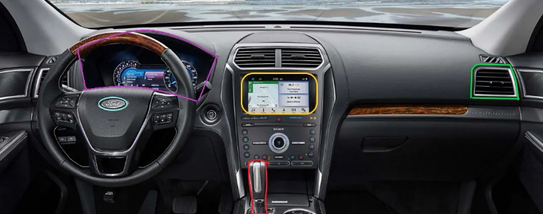

**Technology Implementation:**

1. Vehicle model “input” development
   1. Identification of vehicle characteristics
   2. Landmarks &/or nodal points, others
   3. "Face Print" for the automobile interior
2. Database of sample images of vehicles
3. Deep learning algorithms to analyze the images and identify the vehicle and content
   1. Generate “feature maps” from vehicle interior images through “convolutional layers” of the neural network

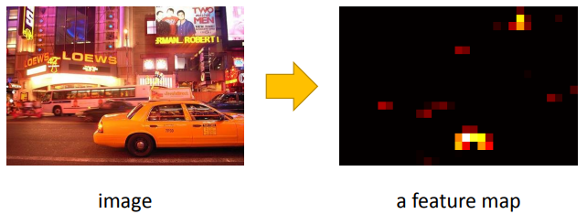 (Source: Kaiming He)

* 1. Use “region proposal network” to auto obtain “region proposals” of images

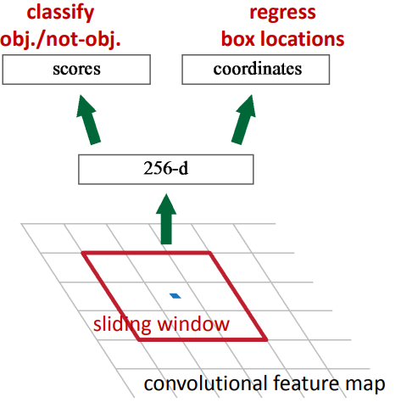 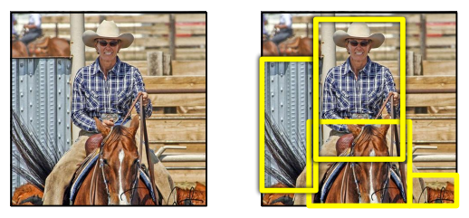 (Source: Kaiming He)

* 1. Based on region proposals, train network to detect the objects through classification and regression to get bounding-boxes
  2. Get instance segmentation through semantic segmentation inside each bounding-boxes

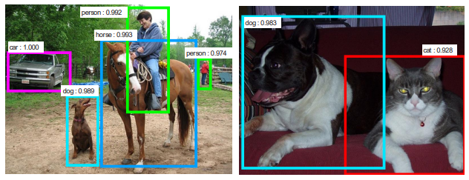 (Source: Kaiming He)

* 1. Apply classification algorithm into the instance detected to get vehicle’s model and feature content